File → New → Project…
Ở ô search gõ: Blank Solution
Chọn Blank Solution
Đặt tên:
- Solution name: LabUnitTest

Tạo Project Core
Chuột phải Solution 'LabUnitTest'
Add → New Project…
Search: Class Library (.NET Framework)
Chọn C# – Class Library (.NET Framework) (không chọn VB)
Next / Create:
- Project name: LabUnitTest.Core
- Framework: .NET Framework 4.8 (hoặc 4.7.2 nếu không có)
Create

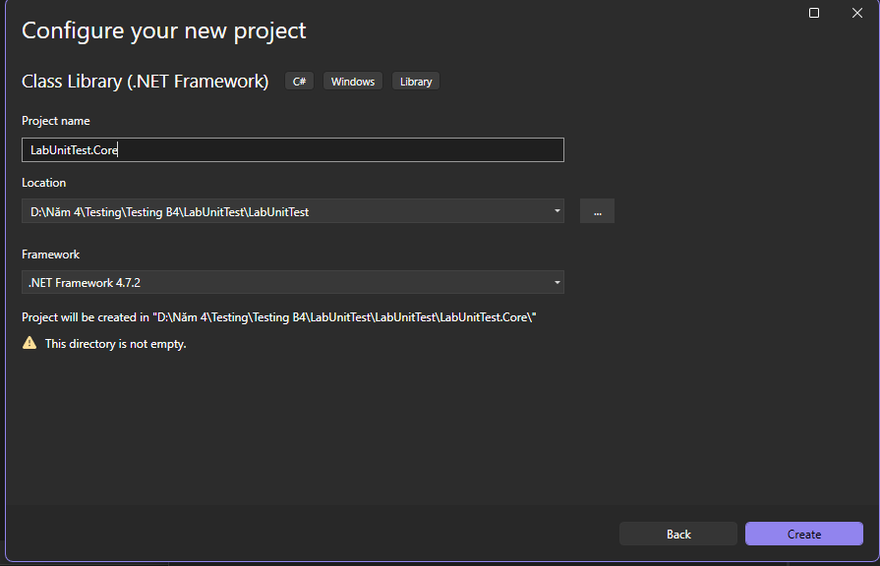
Chuột phải Solution
Add → New Project…
Search: MSTest Test Project (.NET Framework)
Chọn đúng MSTest Test Project (.NET Framework)
Đặt tên:
- LabUnitTest.Tests
Create
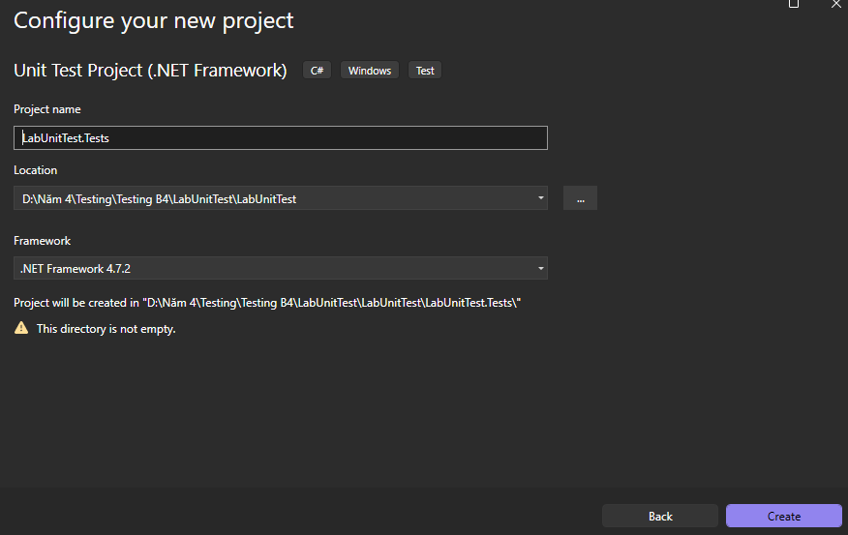
Link Test → Core
Chuột phải LabUnitTest.Tests
Add → Project Reference…
Tick LabUnitTest.Core
OK
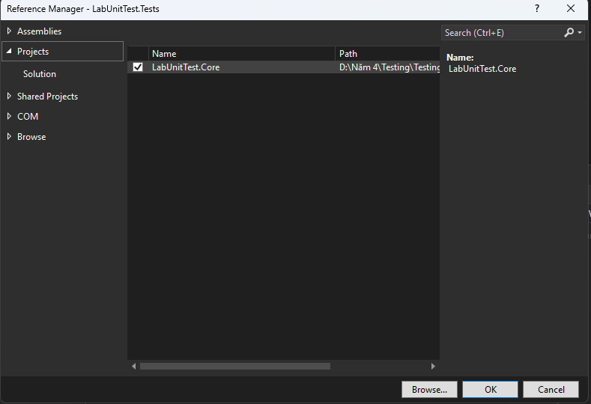
MathEx.cs
public static class MathEx
{
public static double Power(double x, int n)
{
if (n == 0) return 1.0;
if (n > 0) return x * Power(x, n - 1);
return Power(x, n + 1) / x;
}
}

Polynomial.cs
using System;
using System.Collections.Generic;

public class Polynomial
{
private int n;
private List<int> a;

public Polynomial(int n, List<int> a)
{
if (n < 0 || a == null || a.Count != n + 1)
throw new ArgumentException("Invalid Data");

this.n = n;
this.a = a;
}

public int Cal(double x)
{
int result = 0;
for (int i = 0; i <= n; i++)
result += (int)(a[i] * Math.Pow(x, i));
return result;
}
}

Radix.cs
using System;
using System.Collections.Generic;

public class Radix
{
private int number;

public Radix(int number)
{
if (number < 0)
throw new ArgumentException("Invalid Number");
this.number = number;
}

public string ConvertDecimalToAnother(int radix = 2)
{
if (radix < 2 || radix > 16)
throw new ArgumentException("Invalid Radix");

if (number == 0) return "0";

List<string> result = new();
int n = number;

while (n > 0)
{
int value = n % radix;
result.Add(value < 10
? value.ToString()
: "ABCDEF"[value - 10].ToString());
n /= radix;
}

result.Reverse();
return string.Join("", result);
}
}

Diem.cs
public class Diem
{
public double X { get; }
public double Y { get; }

public Diem(double x, double y)
{
X = x;
Y = y;
}
}

HinhChuNhat.cs
using System;

public class HinhChuNhat
{
public Diem TrenTrai { get; }
public Diem DuoiPhai { get; }

public HinhChuNhat(Diem trenTrai, Diem duoiPhai)
{
if (trenTrai == null || duoiPhai == null ||
trenTrai.X >= duoiPhai.X || trenTrai.Y <= duoiPhai.Y)
throw new ArgumentException("Invalid Rectangle");

TrenTrai = trenTrai;
DuoiPhai = duoiPhai;
}

public double DienTich()
{
return (DuoiPhai.X - TrenTrai.X) *
(TrenTrai.Y - DuoiPhai.Y);
}

public bool GiaoNhau(HinhChuNhat other)
{
if (other == null) return false;

return !(DuoiPhai.X < other.TrenTrai.X ||
other.DuoiPhai.X < TrenTrai.X ||
TrenTrai.Y < other.DuoiPhai.Y ||
other.TrenTrai.Y < DuoiPhai.Y);
}
}

HocVien.cs
public class HocVien
{
public string MaSo { get; }
public string HoTen { get; }
public string QueQuan { get; }
public double M1, M2, M3;

public HocVien(string ma, string ten, string qq, double m1, double m2, double m3)
{
MaSo = ma;
HoTen = ten;
QueQuan = qq;
M1 = m1; M2 = m2; M3 = m3;
}

public double DTB() => (M1 + M2 + M3) / 3;

public bool DuHocBong()
=> DTB() >= 8 && M1 >= 5 && M2 >= 5 && M3 >= 5;
}

HocBongService.cs
using System.Collections.Generic;
using System.Linq;

public static class HocBongService
{
public static List<HocVien> LayDanhSachHocBong(List<HocVien> ds)
=> ds.Where(h => h.DuHocBong()).ToList();
}

PowerTests.cs
using Microsoft.VisualStudio.TestTools.UnitTesting;
[TestClass]
public class PowerTests
{
[TestMethod]
public void Power_N_Equal_Zero_Returns_One()
{
Assert.AreEqual(1.0, MathEx.Power(5.7, 0), 1e-12);
}

[TestMethod]
public void Power_Positive_N_Works()
{
Assert.AreEqual(8.0, MathEx.Power(2.0, 3), 1e-12);
Assert.AreEqual(81.0, MathEx.Power(3.0, 4), 1e-12);
}

[TestMethod]
public void Power_Negative_N_Works()
{
Assert.AreEqual(0.25, MathEx.Power(2.0, -2), 1e-12);
Assert.AreEqual(0.5, MathEx.Power(2.0, -1), 1e-12);
}

[TestMethod]
public void Power_Negative_Base_Odd_Even()
{
Assert.AreEqual(-8.0, MathEx.Power(-2.0, 3), 1e-12);
Assert.AreEqual(16.0, MathEx.Power(-2.0, 4), 1e-12);
}
}

PolynomialTests.cs
using Microsoft.VisualStudio.TestTools.UnitTesting;
using System;
using System.Collections.Generic;
// using LabUnitTest.Core;

[TestClass]
public class PolynomialTests
{
[TestMethod]
public void Cal_Returns_Correct_Value()
{
// P(x) = 1 + 2x + 3x^2
var p = new Polynomial(2, new List<int> { 1, 2, 3 });
Assert.AreEqual(17, p.Cal(2));
}

[TestMethod]
[ExpectedException(typeof(ArgumentException))]
public void Ctor_Throws_When_Missing_Coefficients()
{
_ = new Polynomial(2, new List<int> { 1, 2 }); // thiếu 1 hệ số
}

[TestMethod]
public void Ctor_Throws_With_Message_When_Negative_Degree()
{
try
{
_ = new Polynomial(-1, new List<int> { 1 });
Assert.Fail("Expected exception was not thrown.");
}
catch (ArgumentException ex)
{
Assert.AreEqual("Invalid Data", ex.Message);
}
}
}

RadixTests.cs
using Microsoft.VisualStudio.TestTools.UnitTesting;
using System;
// using LabUnitTest.Core;

[TestClass]
public class RadixTests
{
[TestMethod]
public void Convert_To_Binary()
{
var r = new Radix(10);
Assert.AreEqual("1010", r.ConvertDecimalToAnother(2));
}

[TestMethod]
public void Convert_To_Hex_Uses_A_F()
{
var r = new Radix(26);
Assert.AreEqual("1A", r.ConvertDecimalToAnother(16));
}

[TestMethod]
[ExpectedException(typeof(ArgumentException))]
public void Convert_Throws_When_Invalid_Radix_Low()
{
var r = new Radix(10);
r.ConvertDecimalToAnother(1);
}

[TestMethod]
[ExpectedException(typeof(ArgumentException))]
public void Ctor_Throws_When_Number_Negative()
{
_ = new Radix(-5);
}
}

RectangleTests.cs
using Microsoft.VisualStudio.TestTools.UnitTesting;
using System;
// using LabUnitTest.Core;

[TestClass]
public class RectangleTests
{
[TestMethod]
public void Area_Is_Correct()
{
var r = new HinhChuNhat(new Diem(0, 10), new Diem(5, 0));
Assert.AreEqual(50.0, r.DienTich(), 1e-12);
}

[TestMethod]
public void Intersects_When_Overlap()
{
var a = new HinhChuNhat(new Diem(0, 10), new Diem(5, 0));
var b = new HinhChuNhat(new Diem(3, 8), new Diem(8, 2));
Assert.IsTrue(a.GiaoNhau(b));
}

[TestMethod]
public void Not_Intersects_When_Separate()
{
var a = new HinhChuNhat(new Diem(0, 10), new Diem(5, 0));
var b = new HinhChuNhat(new Diem(6, 10), new Diem(9, 0));
Assert.IsFalse(a.GiaoNhau(b));
}

[TestMethod]
[ExpectedException(typeof(ArgumentException))]
public void Ctor_Throws_When_Invalid_Corners()
{
_ = new HinhChuNhat(new Diem(5, 0), new Diem(0, 10));
}
}

ScholarshipTests.cs
using Microsoft.VisualStudio.TestTools.UnitTesting;
using System.Collections.Generic;
// using LabUnitTest.Core;

[TestClass]
public class ScholarshipTests
{
[TestMethod]
public void Eligible_When_Avg_Gte_8_And_No_Subject_Below_5()
{
var hv = new HocVien("HV01", "A", "HCM", 8, 8, 8);
Assert.IsTrue(hv.DuHocBong());
}

[TestMethod]
public void Not_Eligible_When_Any_Subject_Below_5()
{
var hv = new HocVien("HV02", "B", "HCM", 10, 9, 4.9);
Assert.IsFalse(hv.DuHocBong());
}

[TestMethod]
public void Filter_Returns_Only_Eligible_Students()
{
var ds = new List<HocVien>
{
new HocVien("HV01","A","HCM",8,8,8),
new HocVien("HV02","B","HCM",9,9,4),
new HocVien("HV03","C","HCM",10,7,7) // avg=8, môn>=5 => đủ
};

var hb = HocBongService.LayDanhSachHocBong(ds);

Assert.AreEqual(2, hb.Count);
Assert.AreEqual("HV01", hb[0].MaSo);
Assert.AreEqual("HV03", hb[1].MaSo);
}
}

Chạy test
Test → Test Explorer
Run All

